JAVA ASSIGNMENT-03 (10-11-2018)

Program-1:Implement 5 arithmetic operations by using method with return types.

class Arithmetic
{
static int sum(int a,int b)
{
int c=a+b;
return c;
}
static int sub(int a,int b)
{
int d=a-b;
return d;
}
static int mul(int a,int b)
{
int e=a*b;
return e;
}
static float div(float a,int b)
{
float f=a/b;
return f;
}
static float mod(float a,float b)
{
float g=a%b;
return g;
}
}
class TestArithmetic
{
public static void main(String args[])
{
int u=Arithmetic.sum(10,20);
int v=Arithmetic.sub(10,20);
int w=Arithmetic.mul(10,20);
float x=Arithmetic.div(10,20);
float y=Arithmetic.mod(10,20);
System.out.println("addition is "+u);
System.out.println("substraction is "+v);
System.out.println("multiplication is "+w);
System.out.println("division is "+x);
System.out.println("modulus is"+y);
}
}

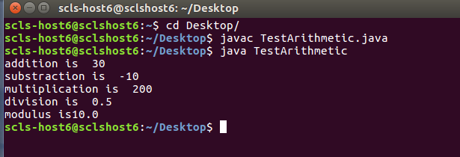

Program-2:Java program to create five employee objects by making company name as static.

class Employee
{
int empno;
String name;
long salary;
static String comName="WIPRO";
Employee(int empno,String name,long salary)
{
this.empno=empno;
this.name=name;
this.salary=salary;
}

void getData()
{
System.out.println("Empno:"+empno);
System.out.println("Name:"+name);
System.out.println("Salary:"+salary);
System.out.println("Company Name:"+comName);
System.out.println("==================================");
}
}
class TestEmployee
{
public static void main(String args[])
{
Employee employee1=new Employee(215,"Harish",25000);
employee1.getData();

Employee employee2=new Employee(222,"Kalyan",35000);
employee2.getData();

Employee employee3=new Employee(225,"Kishore",40000);
employee3.getData();

Employee employee4=new Employee(236,"Rajashekar",20000);
employee4.getData();

Employee employee5=new Employee(258,"vinay",30000);
employee5.getData();
}
}
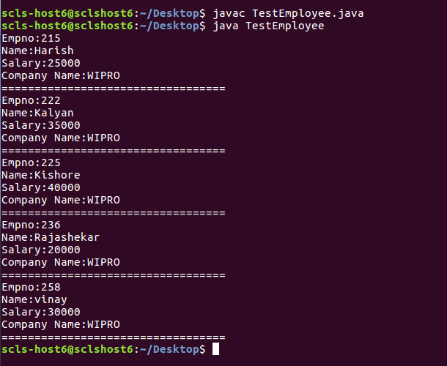

(OR)

class TestEmployee2
{
public static void main(String args[])
{
class Employee
{
int empno;
String name;
long salary;
String comName="WIPRO";

Employee(int empno,String name,long salary)
{
this.salary=salary;
this.empno=empno;
this.name=name;

}

void getData()
{
System.out.println("Empno:"+empno);
System.out.println("Name:"+name);
System.out.println("Salary:"+salary);
System.out.println("Company Name:"+comName);
System.out.println("==================================");
}

}

Employee obj1=new Employee(215,"Harish",25000);

obj1.getData();

Employee obj2=new Employee(216,"Kishore",35000);

obj2.getData();

Employee obj3=new Employee(217,"Rajashekar",24000);

obj3.getData();

Employee obj4=new Employee(218,"Vinay",250000);

obj4.getData();

Employee obj5=new Employee(219,"Raju",25000);

obj5.getData();

}
}

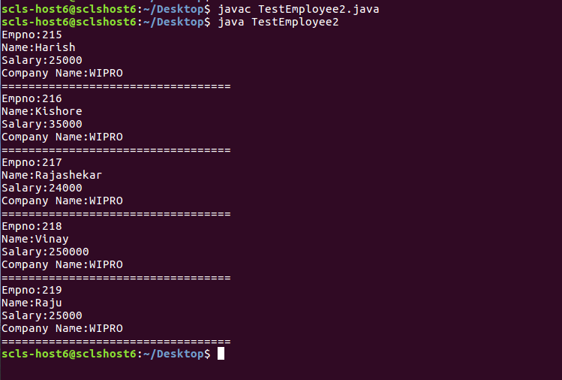

Program-3: Observe compiler and JVM when we put a name other than main method

class Sum
{

int a;
int b;
void setData(int x,int y)
{
a=x;
b=y;
}
void SumOfTwoNumbers()
{
System.out.println("sum is "+(a+b));

}

}
class TestSum
{
public static void main(String args[])

{
Sum obj= new Sum();
obj.setData(12,4);
obj.SumOfTwoNumbers();
}
}



